February 20, 2022

*Sent Via E-mail:* <<OPPOSING_COUNSEL_EMAIL>>

<<OPPOSING_COUNSEL_NAME>>

***RE:*** *<<PROVIDER_SUITNAME>> a/a/o <<INJUREDPARTY_NAME>> v. <<INSURANCECOMPANY_SUITNAME>>, Case No.* <<INDEXORAAA_NUMBER>>

***Settlement Communication: The following confidential communication is intended only for settlement purposes and as an offer of compromise only, and may not be used for any other purpose than as intended.  The following communication is privileged within the meaning and intent of Florida Statute §90.408 and other applicable law and may not be deemed as an admission against interest whether pursuant to Florida Statute §90.803(18) or otherwise.***

To Whom It May Concern,

The purpose of this letter is to propose early settlement of this **lawsuit.**

Our client is willing to accept the sum of $<<BALANCE_AMOUNT>> for indemnity, plus $6,500.00 for its attorney’s fees and costs in full satisfaction of this claim. This is a one-time offer for settlement that is only valid for 5 business days from the receipt of this letter.

In exchange for the payment of the foregoing funds, our client will execute a settlement agreement and/or release limited to the services rendered, and will dismiss the pending lawsuit with prejudice. Please let us know if you accept our offer so we can proceed to file a Notice of Settlement with the court.

Sincerely,

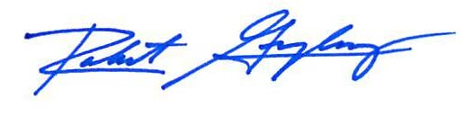

Robert F. Gonzalez, Esq.